# **CHAPTER FOUR**

**4.0 PROJECT PLANNING**

## **4. 1 Project Timeline**

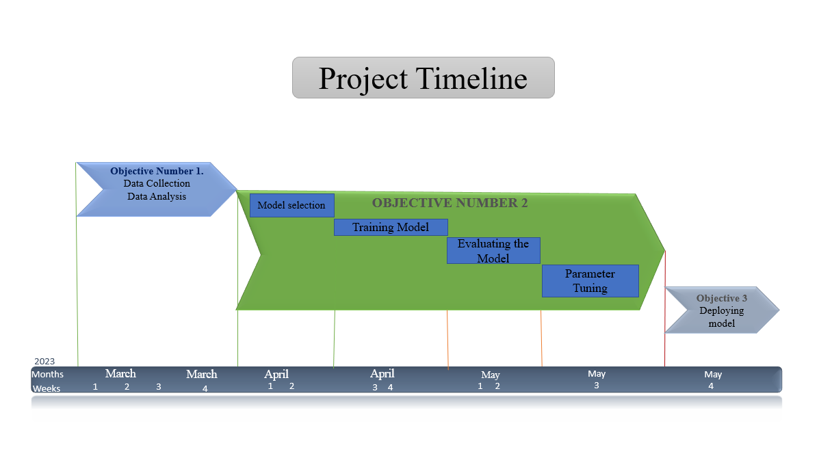

## **4.2 project budget**

